First Author, Second Author
Affiliation
TITLE
SUMMARY
Summary of the main theses of the paper up to 10 lines. This instruction applies to the editorial preparation of the paper. It is also a model for the title page and the text page of the paper. Page and paragraph settings are provided, thanks to which the layout of materials will be standardized.
Keywords:
Word, word, word, small letters.

INTRODUCTION
Introduction to the topic of the paper and results. Introduction to the topic of the paper and results. Introduction to the topic of the paper and results. Introduction to the topic of the paper and results. Introduction to the topic of the paper and results.
Introduction to the topic of the paper and results. Introduction to the topic of the paper and results. Introduction to the topic of the paper and results. Introduction to the topic of the paper and results. Introduction to the topic of the paper and results.

SUBHEADINGS

Main part describing the research methodology and results obtained. Main part describing the research methodology and results obtained. Main part describing the research methodology and results obtained. Main part describing the research methodology and results obtained.
Main part describing the research methodology and results obtained. Main part describing the research methodology and results obtained. Main part describing the research methodology and results obtained. Main part describing the research methodology and results obtained.
Main part describing the research methodology and results obtained. Main part describing the research methodology and results obtained. Main part describing the research methodology and results obtained. Main part describing the research methodology and results obtained.

Subordinate subheadings
Unified numbering in the text. Unified numbering in the text. Unified numbering in the text. Numbering in the text is uniform.Tekst pierwszej pozycji numerowanej.
Dota t the end.
- Text.
- Text of the last numbered position.
Unified bullet points. Unified bullet points. Unified bullet points. Unified bullet points. Unified bullet points.
- text of first enumerated item, semicolon at the end;
- text;
- text of the last enumerated item, dot at the end.
Tables placed in the middle, numbered, their width cannot exceed 13 cm. Tables placed in the middle, numbered, their width cannot exceed 13 cm. Tables placed in the middle, numbered, their width cannot exceed 13 cm.
Table 1. Table title
No. | Chemical composition [%]
No. | Li | Zn | Mg | Mn | Fe | Si | Cu | Zr | Ti
1.1 | 1,15 | 4,60 | 1,15 | 0,20 | 0,15 | 0,18 | 0,12 | 0,14 | 0,03
1.8 | 1,82 | 4,50 | 1,20 | 0,26 | 0,22 | 0,10 | 0,07 | 0,15 | 0,04
2.5 | 2,50 | 4,55 | 1,15 | 0,22 | 0,20 | 0,15 | 0,08 | 0,14 | 0,04
source: Kowalski K., Title, Publisher, Year
Formulas written in the equation editor, placed in the center, numbered at the right margin. Formulas written in the equation editor, placed in the center, numbered at the right margin. Formulas written in the equation editor, placed in the center, numbered at the right margin.
Formulas written in the equation editor, placed in the center, numbered at the right margin. Formulas written in the equation editor, placed in the center, numbered at the right margin. Formulas written in the equation editor, placed in the center, numbered at the right margin.
$σ_{r}=\frac{R_{r}}{ρ_{o}c_{o}S_{o}}=\frac{W_{\text{ac}}}{ρ_{o}c_{o}S_{o}\overline{u^{2}}}=\frac{({\text{ka}}_{o})^{2}}{1+({\text{ka}}_{o})^{2}}\text{.}$ (1)
Drawings placed in the center, numbered, their width must not exceed 13 cm. Drawings placed in the center, numbered, their width must not exceed 13 cm. Drawings placed in the center, numbered, their width must not exceed 13 cm.
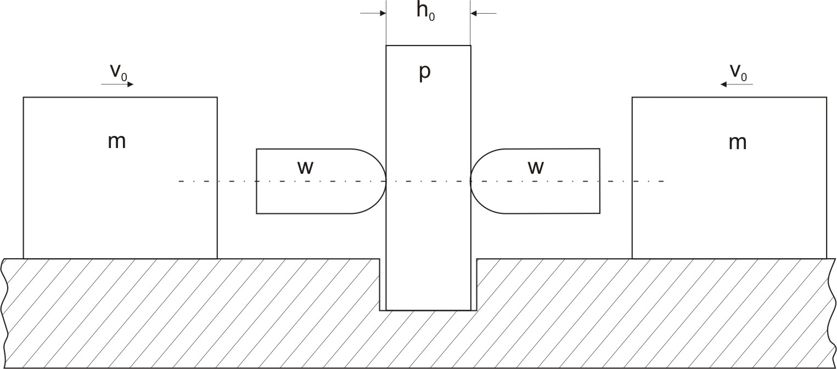
Fig. 1. Sample drawing
source: Kowalski K., Title, Publisher, Year
Drawings should be black and white, placed in the paper and in addition with files with the TIFF, JPEG or GIF extension.
Footnotes with 9.5-point font, single spacing, from paragraph.. Footnotes with 9.5-point font, single spacing, from paragraph.. Footnotes with 9.5-point font, single spacing, from paragraph.

CONCLUSIONS
This printout is an example of formatting text on a page and using the correct font type and size. This printout is an example of formatting text on a page and using the right typeface and font size. This printout is an example of formatting text on a page and using the correct font type and size. This printout is an example of formatting text on a page and using the right typeface and font size

BibliograPHY
- Author (last name, initial), Title, publisher, place and year of publishing.
- Author (last name, initial), Title, [at:], Title, edit. (initial, last name), publisher, place and year of publishing.
- Author (last name, initial), Title, „Title of the periodical”, year, number, pages.
- Author (last name, initial), Title, name of the conference, publisher, place and year, pages.
- Author (last name, initial), Title, owner, number, date
TITLE OF THE PAPER
ABSTRACT
In English. In English. In English. In English. In English. In English. In English. In English. In English. In English. In English. In English. In English. In English. In English. In English. In English. In English. In English. In English. In English. In English. In English. In English. In English.

M. Pacholski, Typy osobowości społecznej a postawy wartości, Kraków 1990, s. 52.
Mianem faktów określa się najczęściej pojedyncze zdarzenia bądź też stany rzeczy zlokalizowane w przestrzeni i czasie. Fakty mogą być jakościowe lub ilościowe. Fakty uzyskane za pomocą metod naukowych, opisane językiem naukowym oraz zweryfikowane w zakresie ich prawidłowości, stają się faktami naukowymi (W. Krajewski, Prawda nauki. Przegląd zagadnień metodologicznych i filozoficznych, Warszawa 1998, s. 29).

